

Design and Implementation of the SETU Campus Library Ontology

Major: MSc Information Systems Processes
Program: Human-centered systems
Student name: Xu Zhiyuan
Student ID: 20115990
Submitted: 4/14/2026

Table of contents
1 Introduction 5
2 Ontology design 5
3 Class Hierarchy 6
4 Object and Data Properties 15
4.1 Object properties 15
4.2 Data Properties 17
5 Individuals and Assertion 18
6 Inconsistency and Limitations 24
6.1 Inconsistency 24
6.2 Restrictions 26
7 Reasoning and Verification 28
8 SPARQL queries and results 28
8.1 Query 1: Lending Relationship (Verify the borrowing relationship between Member and Resource) 29
8.2 Query 2: Verify the relationship between Library and Librarian 30
8.3 Query 3: Verify the relationship between Library and Member 31
8.4 Query 4: Verify the complete borrowing process 32
8.5 Query 5: Verify the relationship between Reservation and StudyRoom / Member 34
9. Ontology Visualization 35
10 Associated data release 41
11 Critical Reflection 42
12 Conclusion 42
13 Appendix (SETU Library System.owl) 43

Table of Figure
Figure 1 Person Class Screenshot 6
Figure 2 Resource Class Screenshot 6
Figure 3 Structure of Class 7
Figure 4 all class 7
Figure 5 Library class 8
Figure 6 Librarian class 9
Figure 7 Member class 9
Figure 8 Book class 10
Figure 9 Jounral class 11
Figure 10 Loan class 11
Figure 11 Library class's objective properties 12
Figure 12 StudyRoom class 13
Figure 13 Reservation class 14
Figure 14 objective properties hierarchy 17
Figure 15 Data properties hierarchy 18
Figure 16 individual member 19
Figure 17 individual librarian 19
Figure 18 Book Individual 20
Figure 19 journal Individual 20
Figure 20 Loan Individual 21
Figure 21 Reservation Individual 22
Figure 22 Member_ZhangWei 22
Figure 23 Loan_001 23
Figure 24 Librarian_Chen 23
Figure 25 Reservation_001 24
Figure 26 disjoint with member 25
Figure 27 disjoint with librarian 25
Figure 28 disjoint journal 26
Figure 29 disjoint book 26
Figure 30 borrows some Resource 27
Figure 31 loanMadeBy exactly 1 Member 27
Figure 32 reservesRoom exactly 1 StudyRoom 27
Figure 33 reasoning tab 28
Figure 34 calendar of reasoning 28
Figure 35 Retrieve all members and their borrowed resources. 30
Figure 36 Verify the relationship between Library and Librarian 31
Figure 37 Verify the relationship between Library and Member 32
Figure 38 verify the complete borrowing process 33
Figure 39 Verify the relationship between Reservation and StudyRoom / Member 35
Figure 40 OntoGraf in Protégé. 36
Figure 41 Library OntoGraf 37
Figure 42 Loan OntoGraf 37
Figure 43 Person OntoGraf 38
Figure 44 Member OntoGraf 38
Figure 45 Libarian OntoGraf 39
Figure 46 Reservation OntoGraf 39
Figure 47 Resource OntoGraf 40
Figure 48 Book OntoGraf 40
Figure 49 Journal OntoGraf 41
Figure 50 Study Room OntoGraf 41

1 Introduction
This report describes the process of designing, developing, and publishing semantic ontologies for campus library systems using Protégé. The purpose of this ontology is to model key entities, relationships, and processes within a university library environment in a structured and semantic manner.
Unlike traditional relational databases, ontology-based modeling enables semantic reasoning, knowledge reuse, and interoperability. The ontology supports querying using SPARQL and follows the principle of linked data and is published online for reuse by other systems and developers.

2 Ontology design
The architecture is designed to be a true reflection of the library's actual operations while maintaining clarity, modularity, and scalability.

The conceptual model consists of the following five main parts:
- User → is represented by "person"
- Resources → are represented by the concept of "resources"
- Library services → represented by “loan” and “Reservation” services
- Physical space → represented by "study rooms"
- Library → represented by " Library "

The "Person" category is further subdivided into "Member" and "Librarian", thus encompassing the different roles in the system.
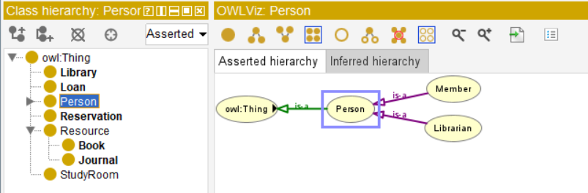
Figure 1 Person Class Screenshot

Similarly, "Resource" is subdivided into "Book" and "Journal", representing different types of materials.
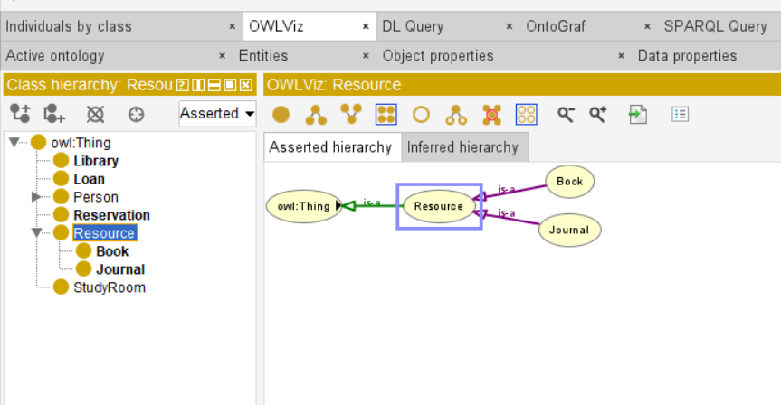
Figure 2 Resource Class Screenshot

Overall, this hierarchy enhances semantic expression and supports inference through inheritance.

3 Class Hierarchy
The body structure is as follows:
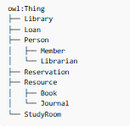
Figure 3 Structure of Class
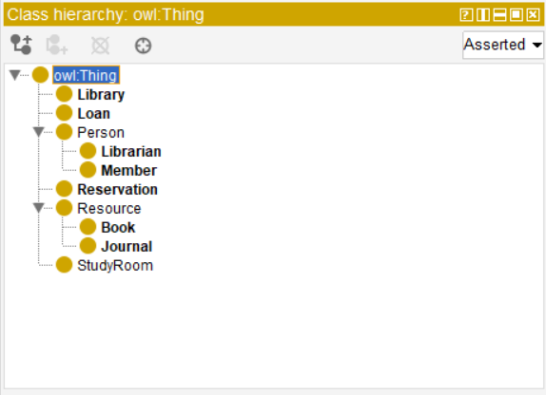
Figure 4 all class
Library Class
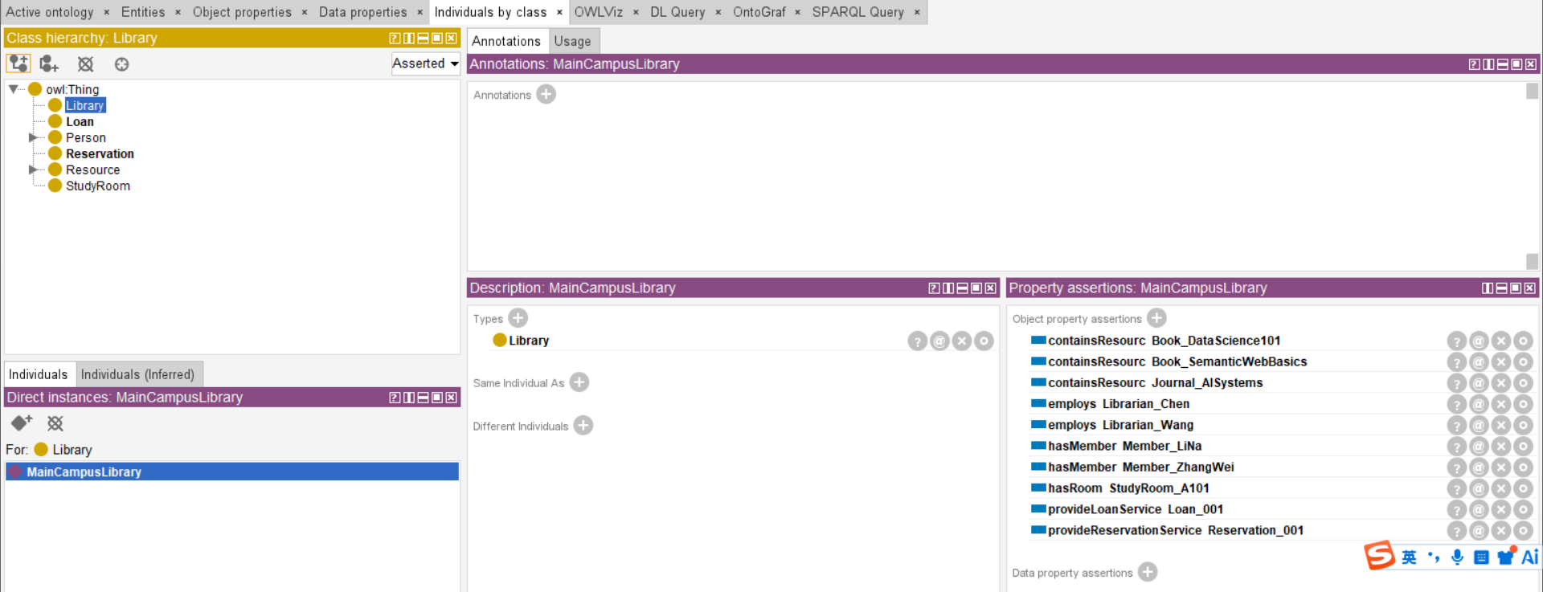
Figure 5 Library class
The Library class acts as a central entity connecting resources, members, staff, and services.
The ontology models both physical structure (rooms, resources) and functional services (loan, reservation).
- Library → person (employs librarian and have members who are interested in reading through employs and hasMember properties)
- Library → resource (borrows books resources to person through borrow properties)
- Library→ Library Service (reservation and loan service through provideService properties)
- Library→ StudyRoom (have physics room for reading through hasRoom properties)

The design reflects real-world library operations, including user management and resource allocation.

Person’s subclass
- Librian class
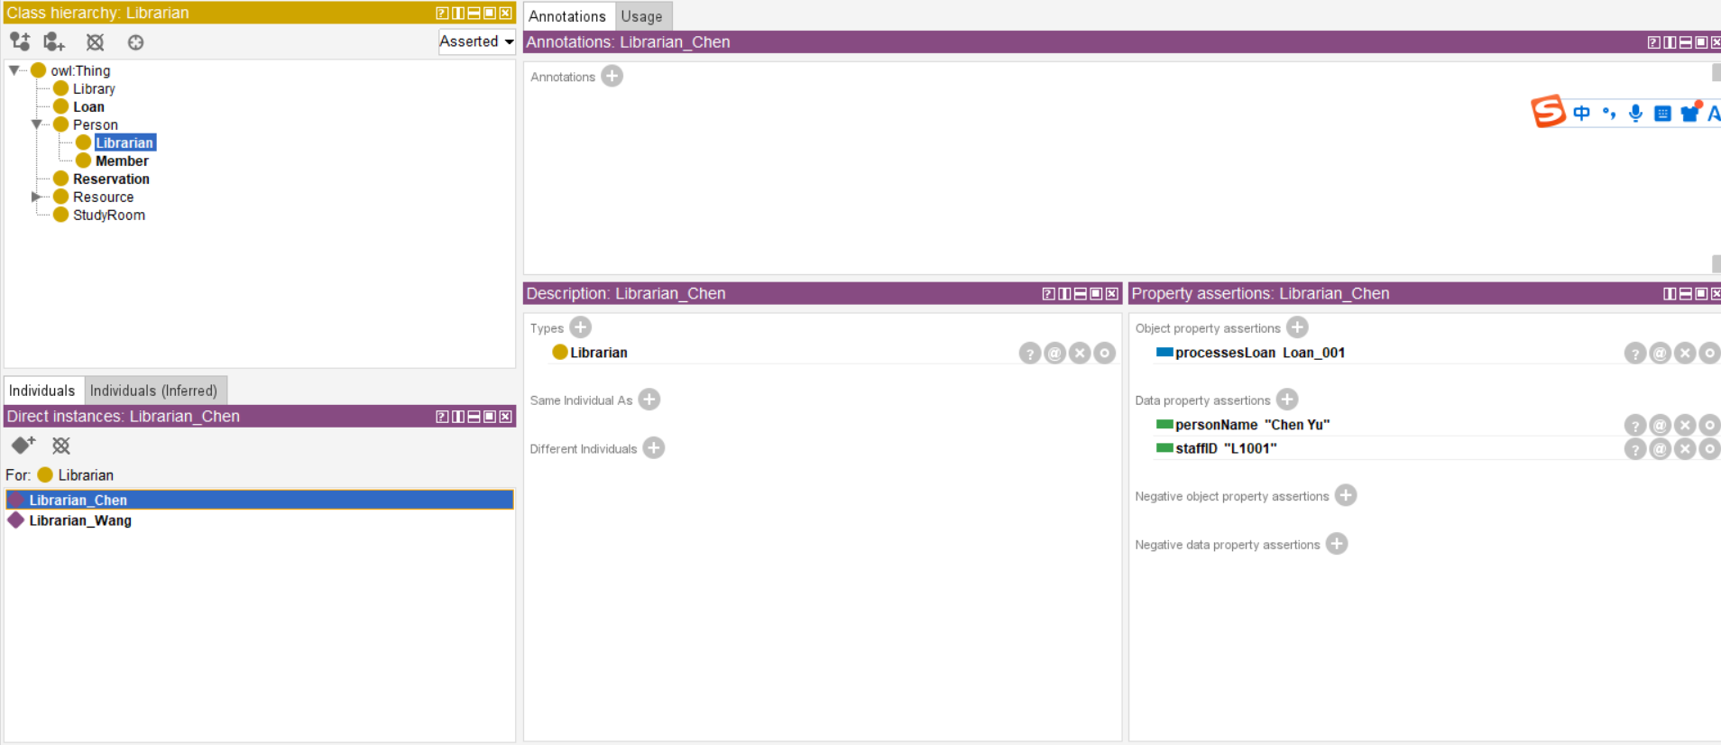
Figure 6 Librarian class

The Librarian class is modeled as a subclass of Person and represents staff responsible for managing library operations.

- Librarian→ Library Service (librarian provide Library Service include loan service)

Librarians are linked to loan processes through the processesLoan property, reflecting their role in handling borrowing transactions.
Additional properties such as staffID and personName are used to store identifying information.
The model can be extended to include responsibilities such as managing sections and handling reservations to better reflect real-world library operations.

- Member class
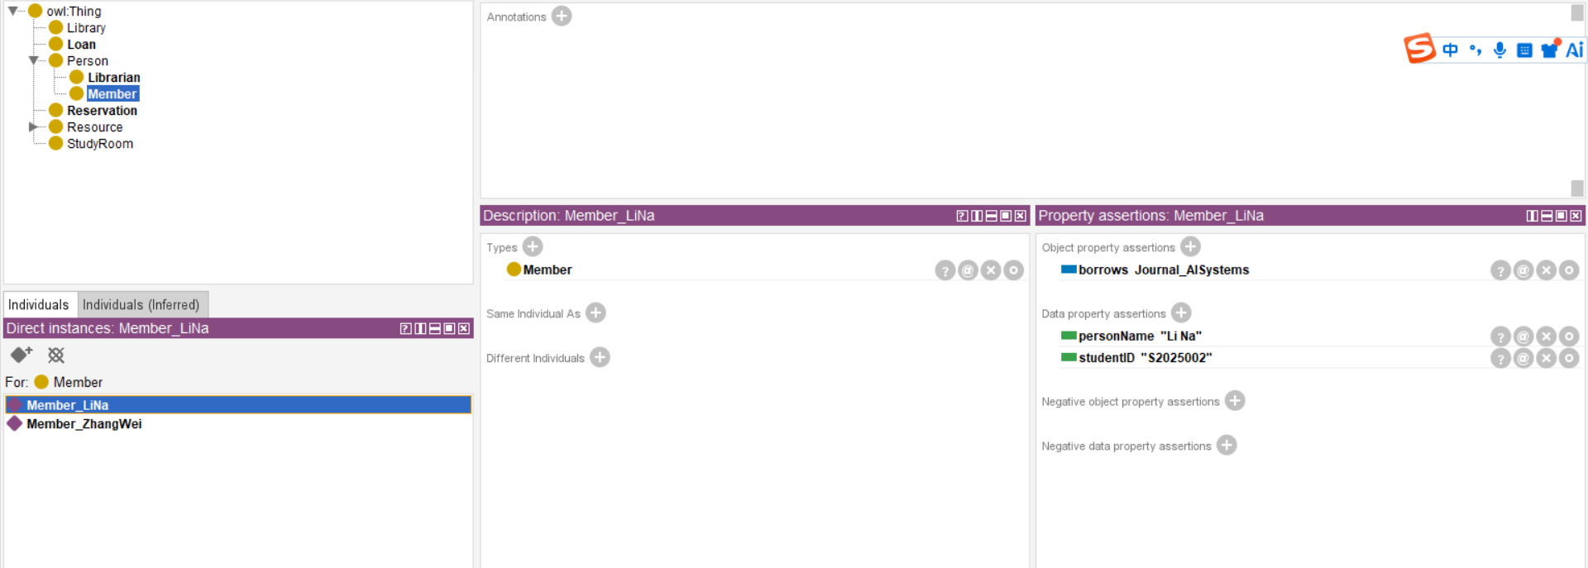
Figure 7 Member class

The Member class is modeled as a subclass of Person and represents library users who can borrow resources.
- Member→ resource (person borrow books in library)
In the ontology, members are linked to library resources through the borrowed property.
Data properties such as personName and studentID are used to capture identifying information.
Resources’ subclass
- Book class
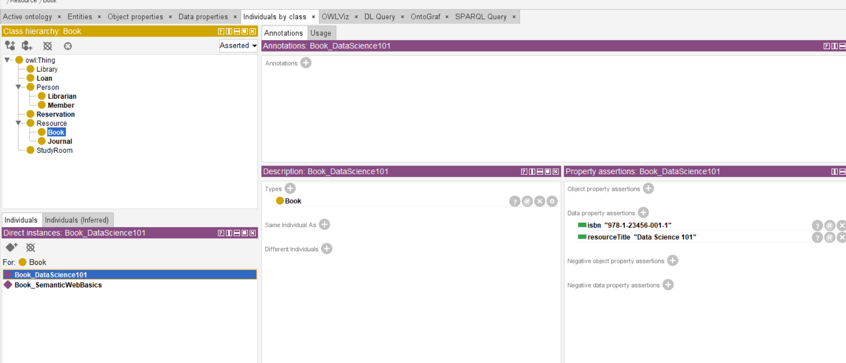
Figure 8 Book class
The Book class is modeled as a subclass of Resource, representing one category of library material.
Each book instance stores descriptive metadata such as resourceTitle and isbn.
This design supports the identification and querying of specific books within the library ontology.
The class can be extended with additional properties such as author and publication year, and linked to borrowing and reservation processes through object properties.

- Journal class
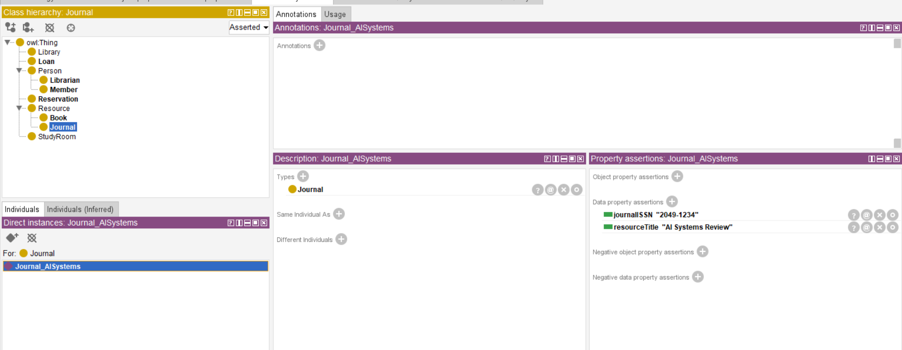
Figure 9 Jounral class
The Journal class is modeled as a subclass of Resource, representing periodical publications such as academic journals.
Each journal is identified using a unique ISSN and a title.
The separation between Book and Journal reflects different types of library materials, improving semantic clarity.
Additional properties such as publisher and publication year can be included to enhance realism.
The class can also be linked to borrowing and reservation processes within the ontology.

Loan class
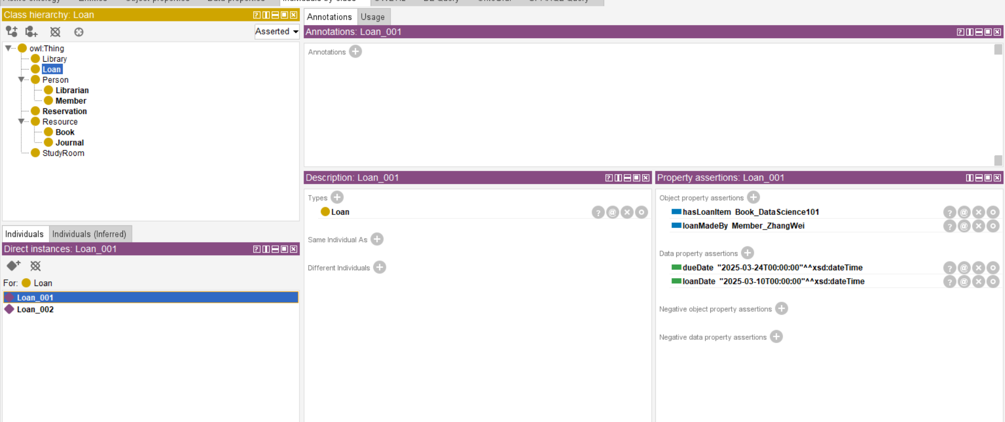
Figure 10 Loan class
The Loan class is modeled as a core transactional class and represents borrowing records in the library system.

- Loan → resource + member (a loan record connects the borrowed item with the library member who made the loan)

In the ontology, loans are linked to library resources through the hasLoanItem property and to members through the loanMadeBy property.
Data properties such as loanDate and dueDate are used to capture borrowing and return deadline information.
This design improves semantic clarity because borrowing is modeled as an independent entity rather than only as a direct relationship between Member and Resource.
To improve semantic precision, the class could be extended with additional properties such as processedBy (Librarian), returnDate, or loanStatus, and restrictions could be added so that each Loan is associated with exactly one member and one resource.

StudyRoom class

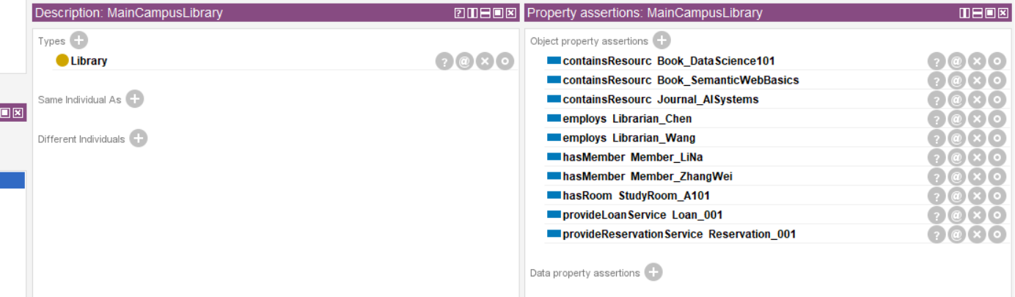
Figure 11 Library class's objective properties
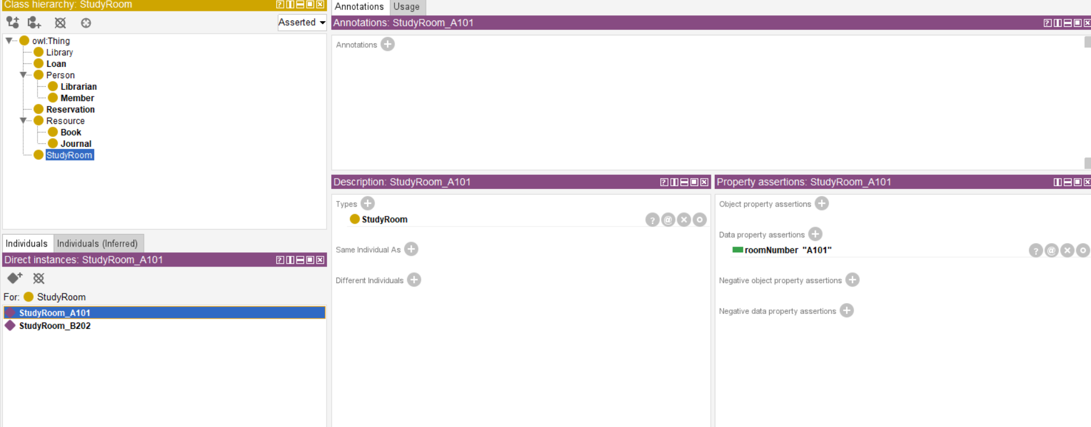
Figure 12 StudyRoom class
The StudyRoom class is modeled as a facility class and represents study spaces in the library system.
- Library →StudyRoom (a study room is a physical space provided by the library for members to study or work through hasRoom properties)
In the ontology, study rooms are used to represent physical rooms available within the library environment.Data properties such as roomNumber are used to capture identifying information for each room.
This design improves semantic clarity because library spaces are modeled as independent entities rather than being treated only as attributes of the Library class.
To improve semantic precision, the class could be extended with additional properties such as capacity, roomType, or availabilityStatus, and object properties could be added to link study rooms with reservations or members who use them.

At the beginning, there were only five classes: Library, Person, Resource, Loan, and StudyRoom. Later, I added another class called Reservation.
Reservation class
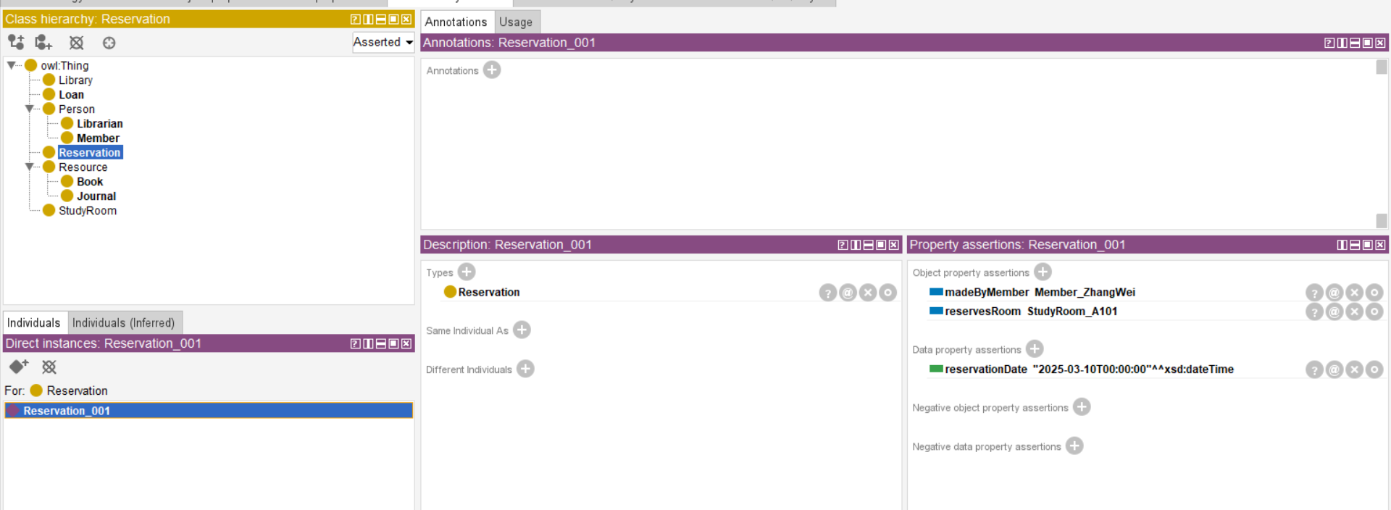
Figure 13 Reservation class
The Reservation class is modeled as a transactional class and represents booking records in the library system.
- Reservation → resource/room + member (a reservation record connects a library member with a reserved resource or study room)
In the ontology, reservations are linked to members through the madeByMember property and to study rooms or resources through the reservesRoom (or resource-related) property.
Data properties such as reservationDate are used to capture the time at which the reservation is made.
This design improves semantic clarity because reservations are modeled as independent entities rather than simple relationships, allowing additional information such as time and status to be recorded.
To improve semantic precision, the class could be extended with additional properties such as reservationStatus, startTime, or endTime, and restrictions could be added so that each Reservation is associated with exactly one member and one reserved item.

This structure can achieve:
- Attribute inheritance from superclass to subclass
If a property is defined for the "Person" entity, such as "hasName" (meaning "has a name"), then:
- Librarian ✔ Automatic inheritance
- Member ✔ Automatic inheritance

- Semantic grouping of related concepts
Similar items have been grouped together:
- Book and Journal → Resource
- Librarian and Member → Person

- Reasoning regarding membership in a category
For example:
- If an object is a Book
→ Then it must also be a Resource.
Or:
- If someone borrows a book → he must be Member

This hierarchical structure enables inheritance functionality and ensures that subclasses can automatically inherit the characteristics of their parent classes.

4 Object and Data Properties

4.1 Object properties
This ontology defines several object properties to represent various relationships:
- hasMember (Library → Member):
The object property hasMember links a Library to its Members, indicating which members belong to a particular library.

- employs (Library → Librarian):
The object property employs links a Library to Librarians, representing staff employed by the library.

- containsResource (Library → Resource):
The object property containsResource links a Library to Resources, showing which resources are available in the library.

- borrows (Member → Resource):
The object property borrows links a Member to a Resource, indicating which resources are borrowed by a member.

- loanMadeBy (Loan → Member):
The object property loanMadeBy links a Loan to a Member, identifying the member who initiated the loan.

- hasLoanItem (Loan → Resource):
The object property hasLoanItem links a Loan to a Resource, specifying which resource is included in the loan.

- processesLoan (Librarian → Loan):
The object property processesLoan links a Librarian to a Loan, indicating which librarian processes the loan transaction.

- madeByMember (Reservation → Member):
The object property madeByMember links a Reservation to a Member, showing who made the reservation.

- reservesRoom (Reservation → StudyRoom):
The object property reservesRoom links a Reservation to a StudyRoom, indicating which study room is reserved.

- provideReservationService (Library → Reservation):
The object property provideReservationService links a Library to a Reservation, indicating that the library offers reservation services to its members.

- provideLoanService (Library → Loan):
The object property provideLoanService links a Library to a Loan, representing the loan services provided by the library.
This property is modeled as a subproperty of hasService, which makes it a more specific kind of service relationship.

- hasRoom (Library → StudyRoom):
The object property hasRoom links a Library to a StudyRoom, showing that the library includes study rooms as part of its facilities.

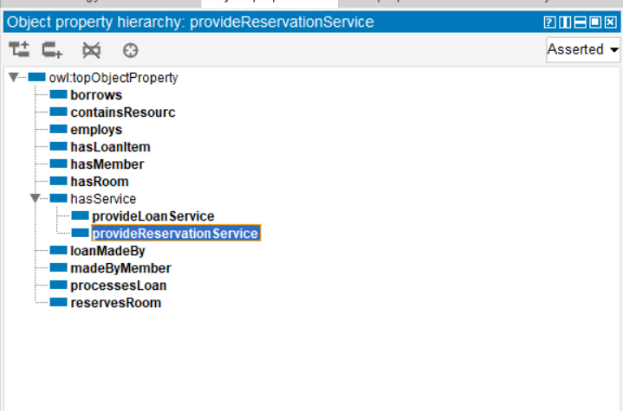
Figure 14 objective properties hierarchy
These object properties help define clear relationships between classes and support reasoning within the ontology. These attributes reflect real-world workflows such as borrowing, processing, and booking. These features capture real-world interactions between entities.

4.2 Data Properties
Data attributes are used to store specific information of individuals, such as names, numbers and dates, etc.
The data attributes defined in the ontology include:
- personName: Used to represent the name of an individual (applicable to Member and Librarian)
- studentID: Used to represent the student ID of a member (Member)
- staffID: Used to represent the employee ID of a librarian (Librarian)
- resourceTitle: Used to represent the name of a resource (such as a book or journal)
- isbn: Used to represent the ISBN number of a book
- journalISSN: Used to represent the ISSN number of a journal
- loanDate: Used to represent the start date of borrowing
- dueDate: Used to represent the deadline for return
- reservationDate: Used to represent the reservation date
- roomNumber: Used to represent the room number of a study room
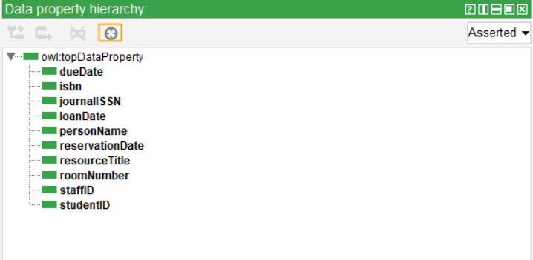
Figure 15 Data properties hierarchy
These data attributes enhance the ability to describe individuals, enabling the ontology to represent more detailed information. At the same time, they support more precise queries and data retrieval, allowing the system to conduct analysis and reasoning based on specific attributes.

5 Individuals and Assertion
The ontology is populated with multiple individuals to simulate a real system.
For example, individuals like Person(father), Member and Librarian(son)
- Members: Member_ZhangWei, Member_LiNa
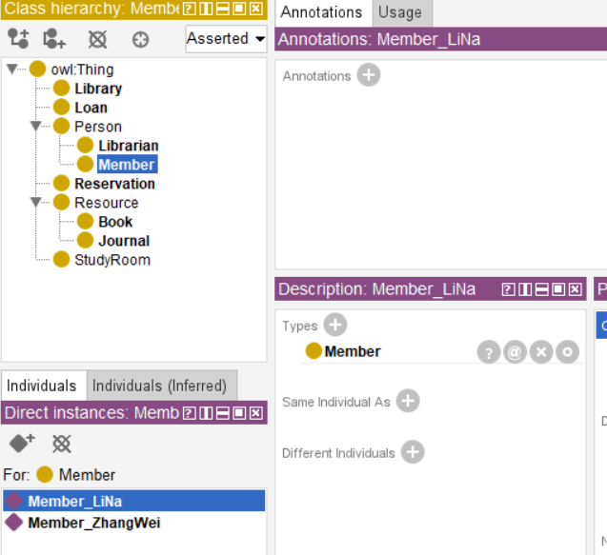
Figure 16 individual member
- Librarian: Librarian_Chen: Librarian_Wang
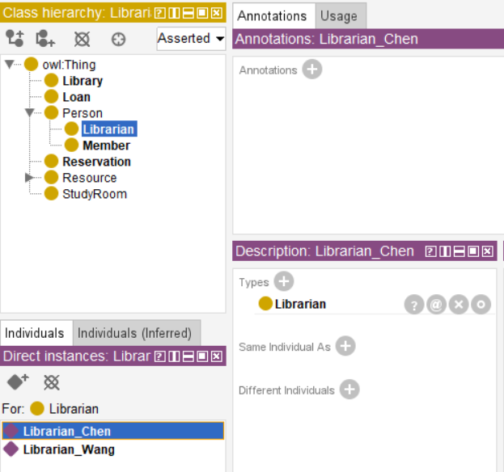
Figure 17 individual librarian

individuals like Resource(father), Book and Journal(son)
- Book and Journal: Book_DataScience101, Journal_AISystems
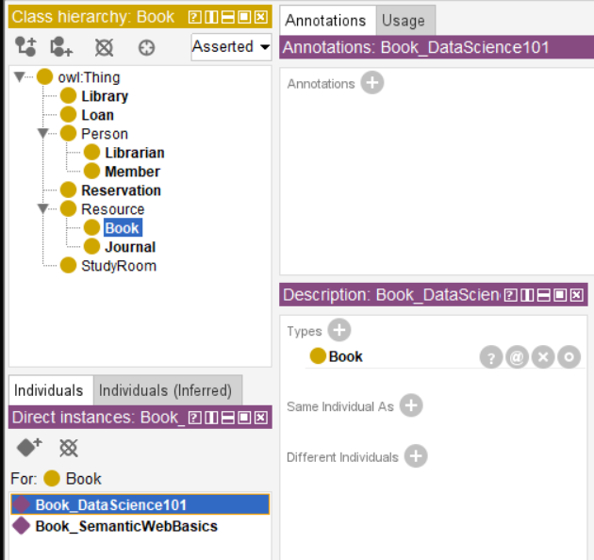
Figure 18 Book Individual

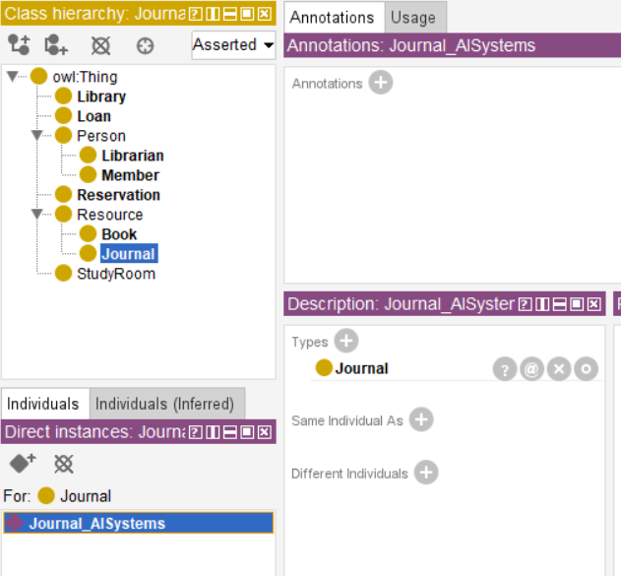
Figure 19 journal Individual

- Loan：Loan_001
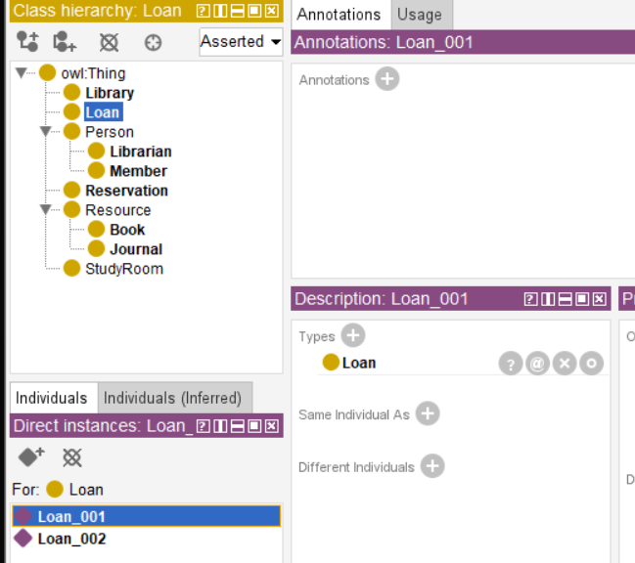
Figure 20 Loan Individual
- Reservation：Reservation_001
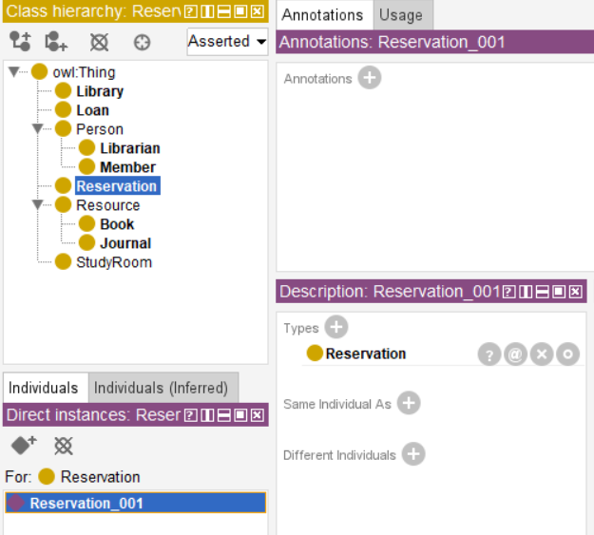
Figure 21 Reservation Individual
Example assertions
- Member_ZhangWei borrows Book_DataScience101
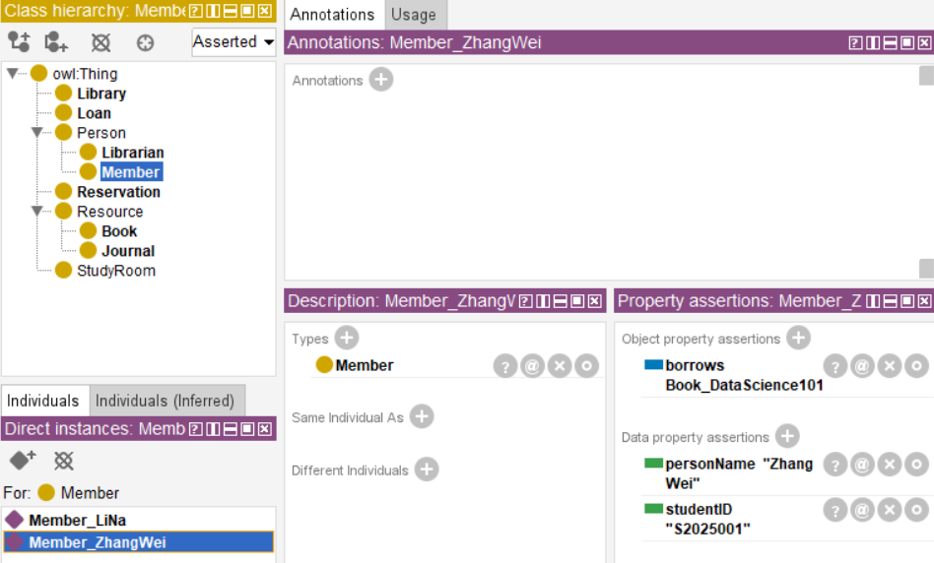
Figure 22 Member_ZhangWei

- Loan_001 loanMadeBy Member_ZhangWei
- Loan_001 hasLoanItem Book_DataScience101
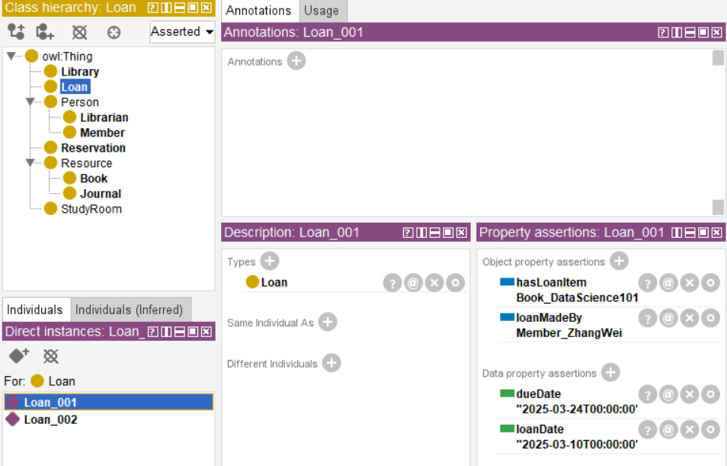
Figure 23 Loan_001
- Librarian_Chen processesLoan Loan_001
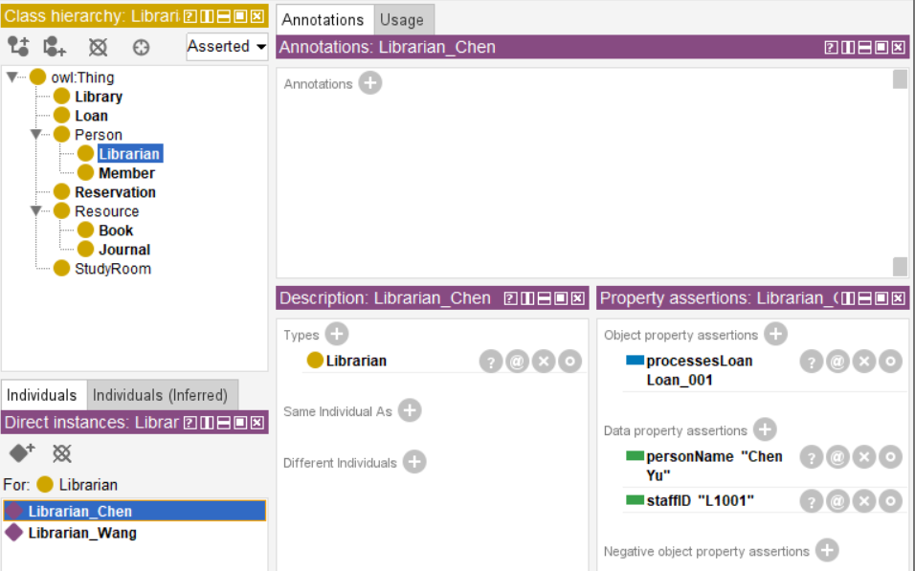
Figure 24 Librarian_Chen
- Reservation_001 reservesRoom StudyRoom_A101
- Reservation_001 madeByNumber Member_ZhangWei
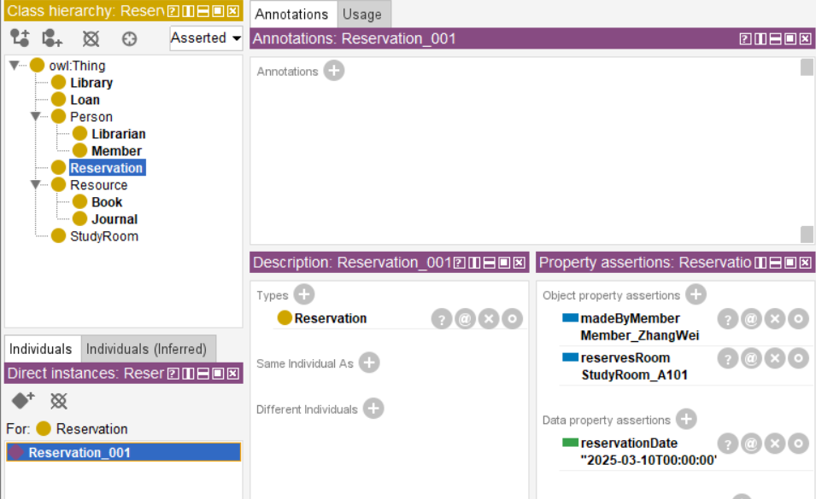
Figure 25 Reservation_001
These assertions show how ontologies model real interactions between entities and explain the relationship between different kinds of individuals to create Library ontology

6 Inconsistency and Limitations

6.1 Inconsistency
To improve semantic precision, inconjunctions are defined:
- Not in the same member category as the librarian
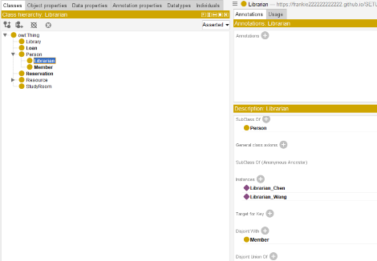
Figure 26 disjoint with member
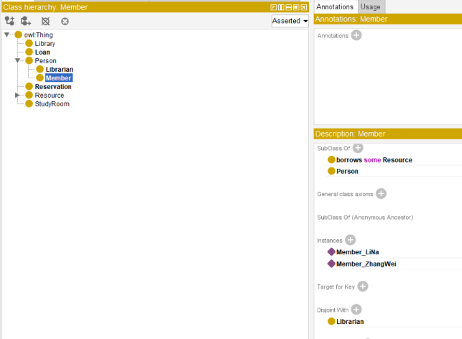
Figure 27 disjoint with librarian
- Books do not match journals
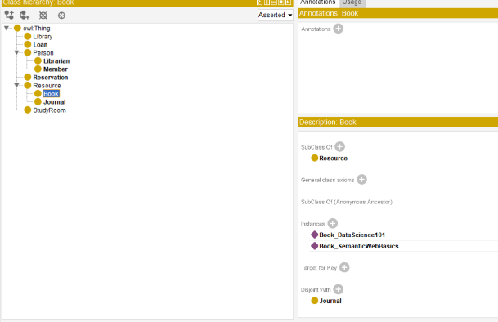
Figure 28 disjoint journal
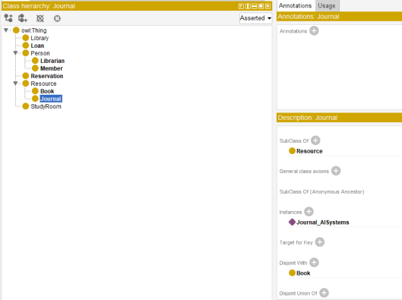
Figure 29 disjoint book
This avoids logical inconsistencies.

6.2 Restrictions
The ontology contains several constraints:
- Member ⊑ borrows some Resource
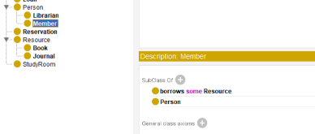
Figure 30 borrows some Resource
- Loan ⊑ loanMadeBy exactly 1 Member
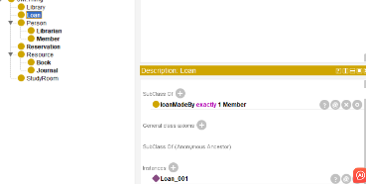
Figure 31 loanMadeBy exactly 1 Member
- Reservation ⊑ reservesRoom exactly 1 StudyRoom
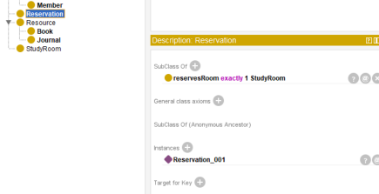
Figure 32 reservesRoom exactly 1 StudyRoom
These limits reflect real-world rules and improve data consistency.

7 Reasoning and Verification
Use the HermiT inference in Protégé for inference.
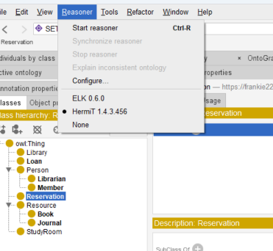
Figure 33 reasoning tab
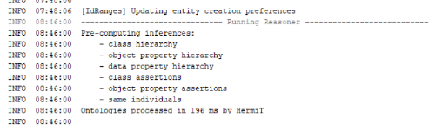
Figure 34 calendar of reasoning
The ontology has been tested and the logic is consistent, and no contradictions have been found. The reasoner successfully deduced:
- Subclass relationships (Member and Librarian as Person)
- Resource classification (Book and Journal as resource)
The imposed limits also ensure effective relationships between individuals, confirming the correctness of the model.

8 SPARQL queries and results
To validate the ontology, we implemented five SPARQL queries. PREFIX used:
PREFIX lib: https://frankie222222222222.github.io/SETU-library-ontology/SETU%20Library%20System.owl#

8.1 Query 1: Lending Relationship (Verify the borrowing relationship between Member and Resource)
Verify：Member → borrows → Resource
Retrieve all members and their borrowed resources.

SPARQL query 1:

PREFIX lib: <https://frankie222222222222.github.io/SETU-library-ontology/SETU%20Library%20System.owl#>

SELECT ?member ?resource
WHERE {
?member a lib:Member .
?member lib:borrows ?resource .
}

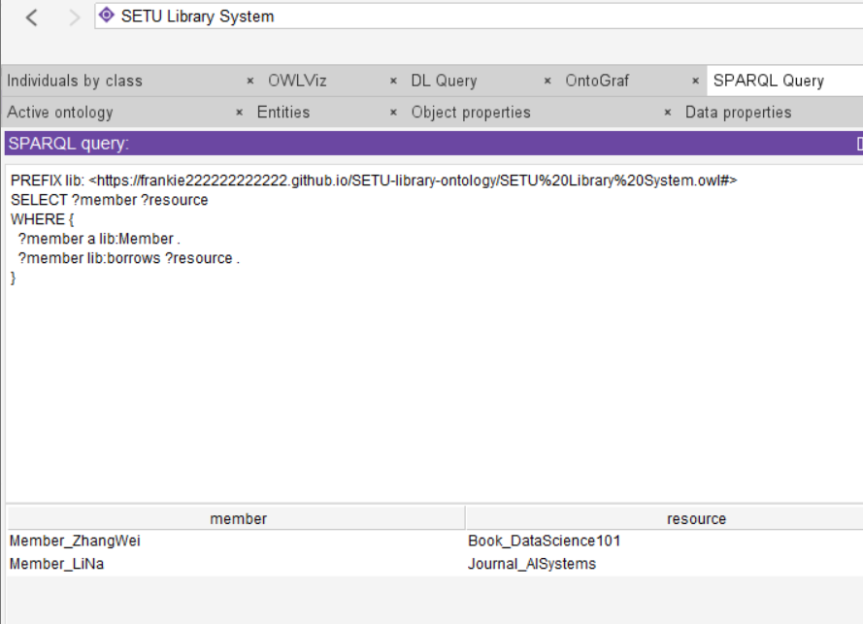
Figure 35 Retrieve all members and their borrowed resources.
Analysis query 1:
Function: This query directly proves that the member borrowed the resource, and it is also one of the most core business relationships in your document. The document clearly defines "borrows" as an object attribute from Member to Resource.

8.2 Query 2: Verify the relationship between Library and Librarian
verify：Library → employs → Librarian
SPARQL query 2:
PREFIX lib: <https://frankie222222222222.github.io/SETU-library-ontology/SETU%20Library%20System.owl#>

SELECT ?library ?librarian ?name
WHERE {
?library a lib:Library .
?library lib:employs ?librarian .
?librarian a lib:Librarian .
?librarian lib:personName ?name .
}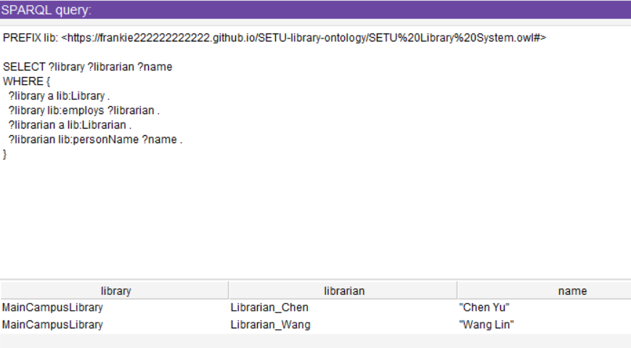
Figure 36 Verify the relationship between Library and Librarian
Analysis query 2:
Function:This query can prove which librarians the library has hired and display their names together. It is more suitable for screenshot presentations.

8.3 Query 3: Verify the relationship between Library and Member
verify：Library → hasMember → Member
SPARQL query 3:

PREFIX lib: <https://frankie222222222222.github.io/SETU-library-ontology/SETU%20Library%20System.owl#>

SELECT ?library ?member
WHERE {
?library a lib:Library .
?library lib:hasMember ?member .
?member a lib:Member .
}

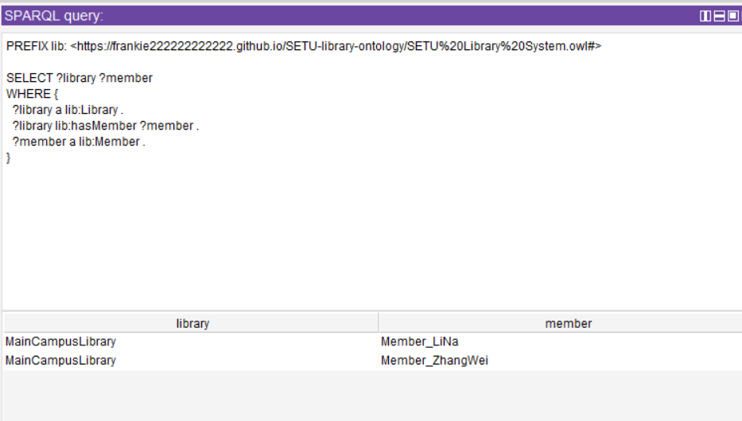
Figure 37 Verify the relationship between Library and Member
Analysis query 3:
Function: This query can prove that a certain Library does indeed have certain Members, which means the subordinate relationship between your library and the members.

8.4 Query 4: Verify the complete borrowing process
verify：Loan → Member + Resource + Librarian
SPARQL query 4:
PREFIX lib: <https://frankie222222222222.github.io/SETU-library-ontology/SETU%20Library%20System.owl#>

SELECT ?loan ?memberName ?resourceTitle ?librarianName ?loanDate ?dueDate
WHERE {
?loan a lib:Loan .
?loan lib:loanMadeBy ?member .
?loan lib:hasLoanItem ?resource .
?member lib:personName ?memberName .
?resource lib:resourceTitle ?resourceTitle .
?librarian lib:processesLoan ?loan .
?librarian lib:personName ?librarianName .
OPTIONAL { ?loan lib:loanDate ?loanDate . }
OPTIONAL { ?loan lib:dueDate ?dueDate . }
}
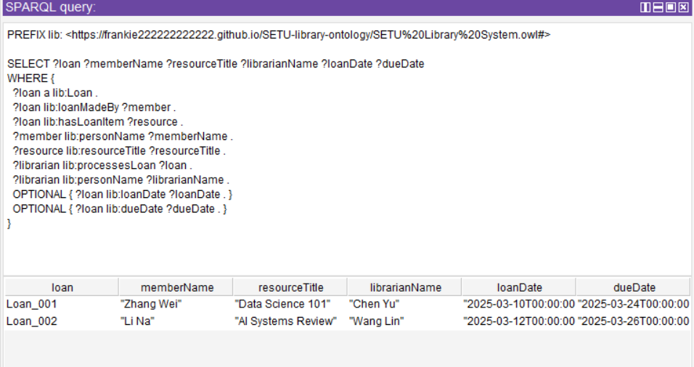
Figure 38 verify the complete borrowing process
Analysis query 4:
Function: This query is the strongest because it conclusively proves the following:
Loan → loanMadeBy → Member
Loan → hasLoanItem → Resource
Librarian → processesLoan → Loan

These three relationships are also regarded as the core of the Loan process.

8.5 Query 5: Verify the relationship between Reservation and StudyRoom / Member

verify：
- Reservation → madeByMember → Member
- Reservation → reservesRoom → StudyRoom
SPARQL query 5:

PREFIX lib: <https://frankie222222222222.github.io/SETU-library-ontology/SETU%20Library%20System.owl#>

SELECT ?reservation ?memberName ?roomNumber ?reservationDate
WHERE {
?reservation a lib:Reservation .
?reservation lib:madeByMember ?member .
?reservation lib:reservesRoom ?room .
?member lib:personName ?memberName .
?room lib:roomNumber ?roomNumber .
OPTIONAL { ?reservation lib:reservationDate ?reservationDate . }
}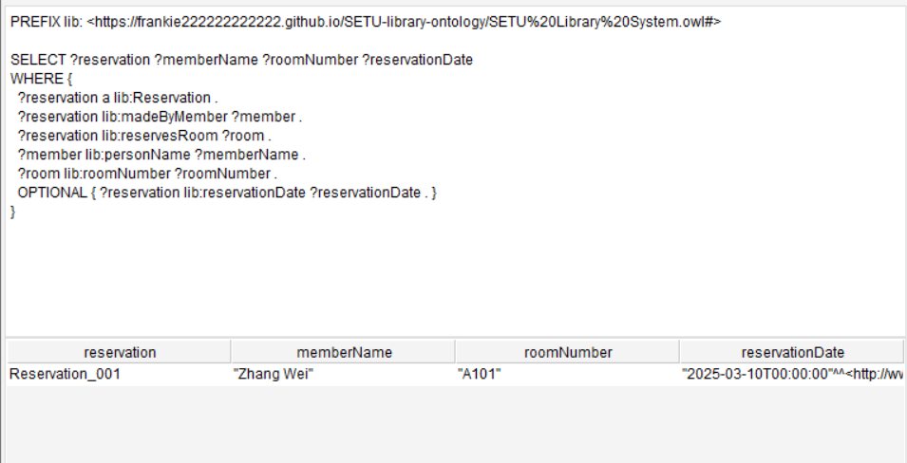
Figure 39 Verify the relationship between Reservation and StudyRoom / Member
Analysis query 5:
Function: This query can prove the following in the appointment records:
- Who made the reservation?
- Which room was reserved?
- What was the reservation time?

Summarize (five SPARQL):
These five SPARQL queries were designed to verify the main semantic relationships in the campus library ontology.
They validate links between libraries, members, librarians, resources, loans, and reservations, showing that the ontology supports meaningful retrieval and relationship-based reasoning.

9. Ontology Visualization
The ontology was visualised using OntoGraf in Protégé.
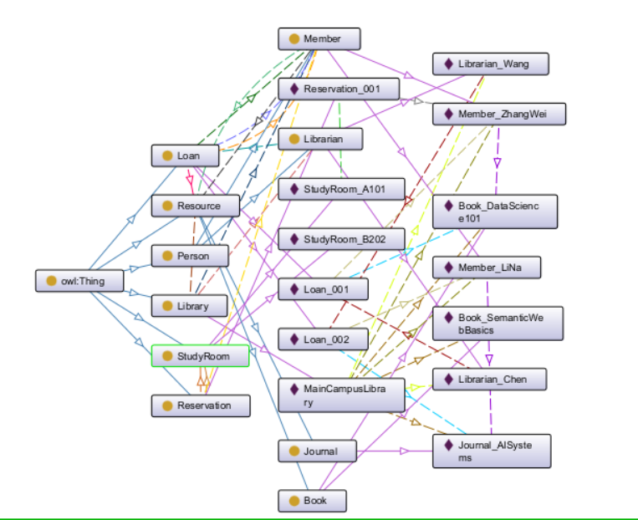
Figure 40 OntoGraf in Protégé.
The visualisation highlights the relationships between classes and demonstrates a clear and modular structure.

Library OntoGraf
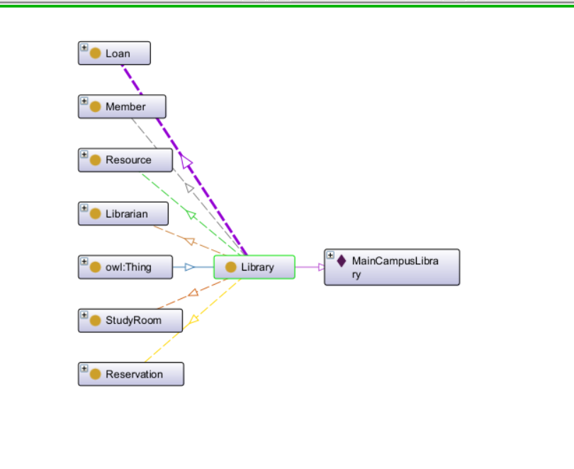
Figure 41 Library OntoGraf

Loan OntoGraf
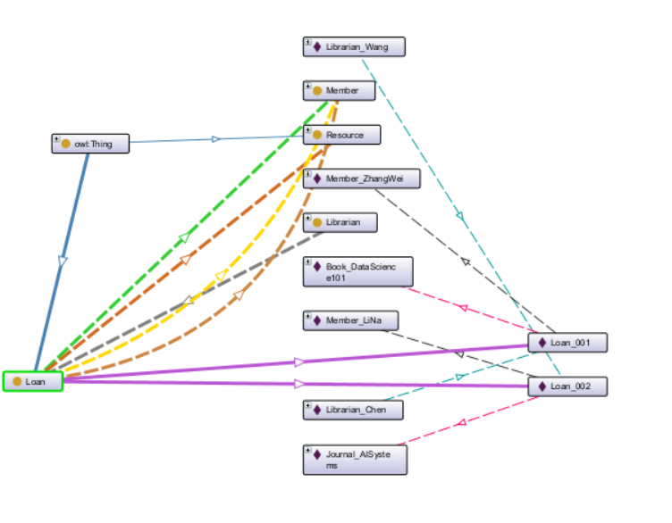
Figure 42 Loan OntoGraf

Person OntoGraf
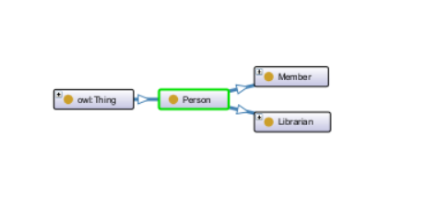
Figure 43 Person OntoGraf

Member OntoGraf
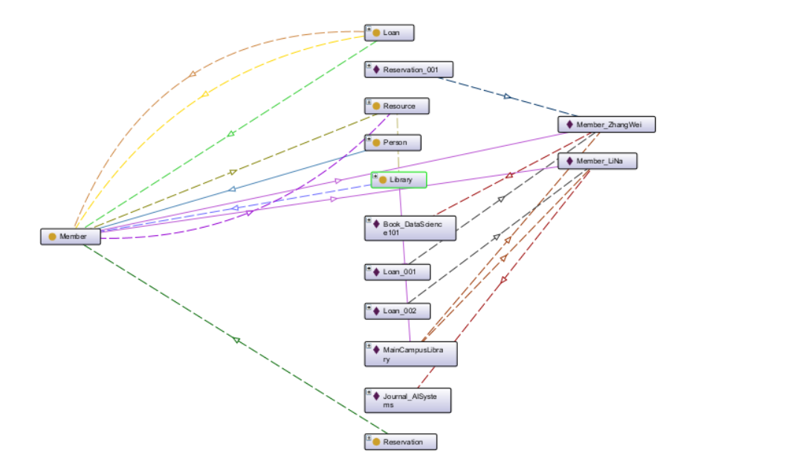
Figure 44 Member OntoGraf

Libarian OntoGraf
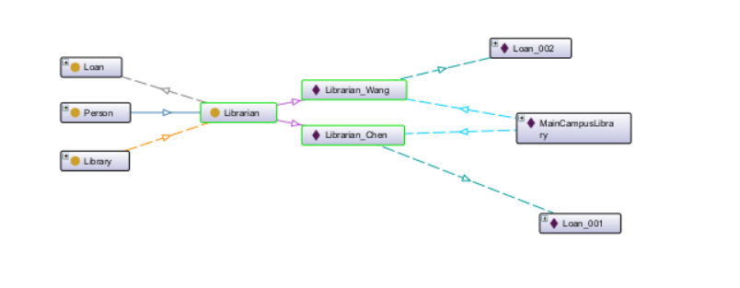
Figure 45 Libarian OntoGraf

Reservation OntoGraf
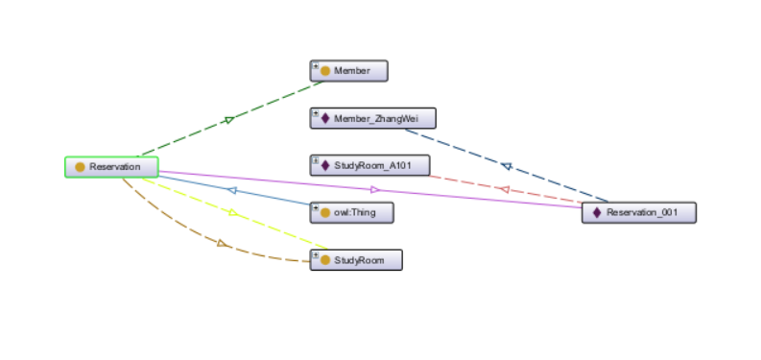
Figure 46 Reservation OntoGraf

Resource OntoGraf
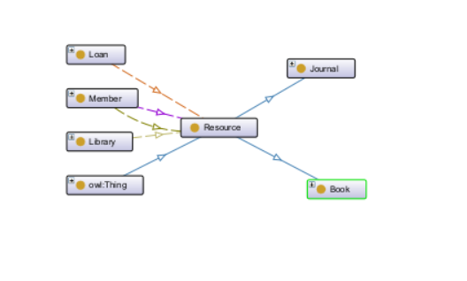
Figure 47 Resource OntoGraf

Book OntoGraf
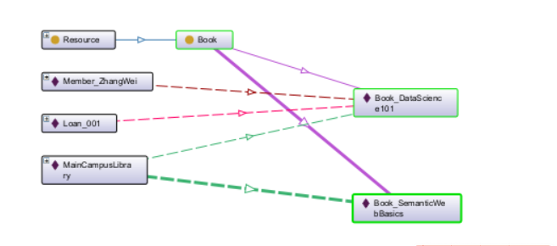
Figure 48 Book OntoGraf

Journal OntoGraf
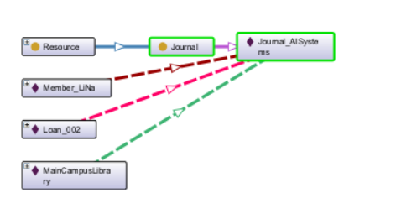
Figure 49 Journal OntoGraf

Study Room OntoGraf
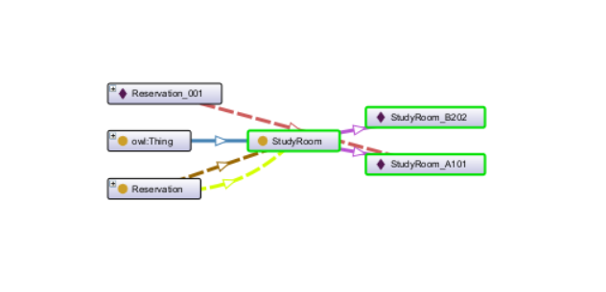
Figure 50 Study Room OntoGraf

10 Associated data release
The ontology was exported as an OWL file and published via GitHub and GitHub Pages.
Public Ontology introduction website:
https://frankie222222222222.github.io/SETU-library-ontology/
Public Ontology download report:
https://github.com/Frankie222222222222/SETU-library-ontology

Public Ontology owl file: https://github.com/Frankie222222222222/SETU-library-ontology/blob/main/SETU%20Library%20System.owl

By distributing a public IRI and hosting the ontology online, it becomes a reusable semantic web resource. Other developers and researchers can reuse or extend this ontology in the following applications:
- Library management system
- Digital repositories
- Knowledge graph platform
This is consistent with the principle of correlation data and body reuse.

11 Critical Reflection
This ontology demonstrates the advantages of semantic modeling over traditional data structures. It captures the structural and logical features of the library system using class hierarchies, object properties, and constraints.
However, this ontology can be further improved by:
- Add support for digital resources, such as e-books
- Introducing penalty management measures for overdue loans
- Extend booking logic with time slots
These improvements will make Ontologies more applicable to real-world systems.

12 Conclusion
The campus library ontology successfully models key entities, relationships, and constraints within a semantic framework. It supports inference, querying, and reuse, making it suitable for integration into semantic web applications.
This ontology demonstrates how knowledge representation technology can be applied to real-world systems, setting the stage for future expansion and application.

13 Appendix (SETU Library System.owl)
<?xml version="1.0"?>
<Ontology xmlns="http://www.w3.org/2002/07/owl#"
xml:base="https://frankie222222222222.github.io/SETU-library-ontology/SETU%20Library%20System.owl"
xmlns:rdf="http://www.w3.org/1999/02/22-rdf-syntax-ns#"
xmlns:xml="http://www.w3.org/XML/1998/namespace"
xmlns:xsd="http://www.w3.org/2001/XMLSchema#"
xmlns:rdfs="http://www.w3.org/2000/01/rdf-schema#"
ontologyIRI="https://frankie222222222222.github.io/SETU-library-ontology/SETU%20Library%20System.owl">
<Prefix name="" IRI="https://frankie222222222222.github.io/SETU-library-ontology/30/"/>
<Prefix name="owl" IRI="http://www.w3.org/2002/07/owl#"/>
<Prefix name="rdf" IRI="http://www.w3.org/1999/02/22-rdf-syntax-ns#"/>
<Prefix name="xml" IRI="http://www.w3.org/XML/1998/namespace"/>
<Prefix name="xsd" IRI="http://www.w3.org/2001/XMLSchema#"/>
<Prefix name="rdfs" IRI="http://www.w3.org/2000/01/rdf-schema#"/>
<Declaration>
<Class IRI="#Book"/>
</Declaration>
<Declaration>
<Class IRI="#Journal"/>
</Declaration>
<Declaration>
<Class IRI="#Librarian"/>
</Declaration>
<Declaration>
<Class IRI="#Library"/>
</Declaration>
<Declaration>
<Class IRI="#Loan"/>
</Declaration>
<Declaration>
<Class IRI="#Member"/>
</Declaration>
<Declaration>
<Class IRI="#Person"/>
</Declaration>
<Declaration>
<Class IRI="#Reservation"/>
</Declaration>
<Declaration>
<Class IRI="#Resource"/>
</Declaration>
<Declaration>
<Class IRI="#StudyRoom"/>
</Declaration>
<Declaration>
<ObjectProperty IRI="#borrows"/>
</Declaration>
<Declaration>
<ObjectProperty IRI="#containsResourc"/>
</Declaration>
<Declaration>
<ObjectProperty IRI="#employs"/>
</Declaration>
<Declaration>
<ObjectProperty IRI="#hasLoanItem"/>
</Declaration>
<Declaration>
<ObjectProperty IRI="#hasMember"/>
</Declaration>
<Declaration>
<ObjectProperty IRI="#hasRoom"/>
</Declaration>
<Declaration>
<ObjectProperty IRI="#hasService"/>
</Declaration>
<Declaration>
<ObjectProperty IRI="#loanMadeBy"/>
</Declaration>
<Declaration>
<ObjectProperty IRI="#madeByMember"/>
</Declaration>
<Declaration>
<ObjectProperty IRI="#processesLoan"/>
</Declaration>
<Declaration>
<ObjectProperty IRI="#provideLoanService"/>
</Declaration>
<Declaration>
<ObjectProperty IRI="#provideReservationService"/>
</Declaration>
<Declaration>
<ObjectProperty IRI="#reservesRoom"/>
</Declaration>
<Declaration>
<DataProperty IRI="#dueDate"/>
</Declaration>
<Declaration>
<DataProperty IRI="#isbn"/>
</Declaration>
<Declaration>
<DataProperty IRI="#journalISSN"/>
</Declaration>
<Declaration>
<DataProperty IRI="#loanDate"/>
</Declaration>
<Declaration>
<DataProperty IRI="#personName"/>
</Declaration>
<Declaration>
<DataProperty IRI="#reservationDate"/>
</Declaration>
<Declaration>
<DataProperty IRI="#resourceTitle"/>
</Declaration>
<Declaration>
<DataProperty IRI="#roomNumber"/>
</Declaration>
<Declaration>
<DataProperty IRI="#staffID"/>
</Declaration>
<Declaration>
<DataProperty IRI="#studentID"/>
</Declaration>
<Declaration>
<NamedIndividual IRI="#Book_DataScience101"/>
</Declaration>
<Declaration>
<NamedIndividual IRI="#Book_SemanticWebBasics"/>
</Declaration>
<Declaration>
<NamedIndividual IRI="#Journal_AISystems"/>
</Declaration>
<Declaration>
<NamedIndividual IRI="#Librarian_Chen"/>
</Declaration>
<Declaration>
<NamedIndividual IRI="#Librarian_Wang"/>
</Declaration>
<Declaration>
<NamedIndividual IRI="#Loan_001"/>
</Declaration>
<Declaration>
<NamedIndividual IRI="#Loan_002"/>
</Declaration>
<Declaration>
<NamedIndividual IRI="#MainCampusLibrary"/>
</Declaration>
<Declaration>
<NamedIndividual IRI="#Member_LiNa"/>
</Declaration>
<Declaration>
<NamedIndividual IRI="#Member_ZhangWei"/>
</Declaration>
<Declaration>
<NamedIndividual IRI="#Reservation_001"/>
</Declaration>
<Declaration>
<NamedIndividual IRI="#StudyRoom_A101"/>
</Declaration>
<Declaration>
<NamedIndividual IRI="#StudyRoom_B202"/>
</Declaration>
<SubClassOf>
<Class IRI="#Book"/>
<Class IRI="#Resource"/>
</SubClassOf>
<SubClassOf>
<Class IRI="#Journal"/>
<Class IRI="#Resource"/>
</SubClassOf>
<SubClassOf>
<Class IRI="#Librarian"/>
<Class IRI="#Person"/>
</SubClassOf>
<SubClassOf>
<Class IRI="#Loan"/>
<ObjectExactCardinality cardinality="1">
<ObjectProperty IRI="#loanMadeBy"/>
<Class IRI="#Member"/>
</ObjectExactCardinality>
</SubClassOf>
<SubClassOf>
<Class IRI="#Member"/>
<Class IRI="#Person"/>
</SubClassOf>
<SubClassOf>
<Class IRI="#Member"/>
<ObjectSomeValuesFrom>
<ObjectProperty IRI="#borrows"/>
<Class IRI="#Resource"/>
</ObjectSomeValuesFrom>
</SubClassOf>
<SubClassOf>
<Class IRI="#Reservation"/>
<ObjectExactCardinality cardinality="1">
<ObjectProperty IRI="#reservesRoom"/>
<Class IRI="#StudyRoom"/>
</ObjectExactCardinality>
</SubClassOf>
<DisjointClasses>
<Class IRI="#Book"/>
<Class IRI="#Journal"/>
</DisjointClasses>
<DisjointClasses>
<Class IRI="#Librarian"/>
<Class IRI="#Member"/>
</DisjointClasses>
<ClassAssertion>
<Class IRI="#Book"/>
<NamedIndividual IRI="#Book_DataScience101"/>
</ClassAssertion>
<ClassAssertion>
<Class IRI="#Book"/>
<NamedIndividual IRI="#Book_SemanticWebBasics"/>
</ClassAssertion>
<ClassAssertion>
<Class IRI="#Journal"/>
<NamedIndividual IRI="#Journal_AISystems"/>
</ClassAssertion>
<ClassAssertion>
<Class IRI="#Librarian"/>
<NamedIndividual IRI="#Librarian_Chen"/>
</ClassAssertion>
<ClassAssertion>
<Class IRI="#Librarian"/>
<NamedIndividual IRI="#Librarian_Wang"/>
</ClassAssertion>
<ClassAssertion>
<Class IRI="#Loan"/>
<NamedIndividual IRI="#Loan_001"/>
</ClassAssertion>
<ClassAssertion>
<Class IRI="#Loan"/>
<NamedIndividual IRI="#Loan_002"/>
</ClassAssertion>
<ClassAssertion>
<Class IRI="#Library"/>
<NamedIndividual IRI="#MainCampusLibrary"/>
</ClassAssertion>
<ClassAssertion>
<Class IRI="#Member"/>
<NamedIndividual IRI="#Member_LiNa"/>
</ClassAssertion>
<ClassAssertion>
<Class IRI="#Member"/>
<NamedIndividual IRI="#Member_ZhangWei"/>
</ClassAssertion>
<ClassAssertion>
<Class IRI="#Reservation"/>
<NamedIndividual IRI="#Reservation_001"/>
</ClassAssertion>
<ClassAssertion>
<Class IRI="#StudyRoom"/>
<NamedIndividual IRI="#StudyRoom_A101"/>
</ClassAssertion>
<ClassAssertion>
<Class IRI="#StudyRoom"/>
<NamedIndividual IRI="#StudyRoom_B202"/>
</ClassAssertion>
<ObjectPropertyAssertion>
<ObjectProperty IRI="#processesLoan"/>
<NamedIndividual IRI="#Librarian_Chen"/>
<NamedIndividual IRI="#Loan_001"/>
</ObjectPropertyAssertion>
<ObjectPropertyAssertion>
<ObjectProperty IRI="#processesLoan"/>
<NamedIndividual IRI="#Librarian_Wang"/>
<NamedIndividual IRI="#Loan_002"/>
</ObjectPropertyAssertion>
<ObjectPropertyAssertion>
<ObjectProperty IRI="#hasLoanItem"/>
<NamedIndividual IRI="#Loan_001"/>
<NamedIndividual IRI="#Book_DataScience101"/>
</ObjectPropertyAssertion>
<ObjectPropertyAssertion>
<ObjectProperty IRI="#loanMadeBy"/>
<NamedIndividual IRI="#Loan_001"/>
<NamedIndividual IRI="#Member_ZhangWei"/>
</ObjectPropertyAssertion>
<ObjectPropertyAssertion>
<ObjectProperty IRI="#hasLoanItem"/>
<NamedIndividual IRI="#Loan_002"/>
<NamedIndividual IRI="#Journal_AISystems"/>
</ObjectPropertyAssertion>
<ObjectPropertyAssertion>
<ObjectProperty IRI="#loanMadeBy"/>
<NamedIndividual IRI="#Loan_002"/>
<NamedIndividual IRI="#Member_LiNa"/>
</ObjectPropertyAssertion>
<ObjectPropertyAssertion>
<ObjectProperty IRI="#containsResourc"/>
<NamedIndividual IRI="#MainCampusLibrary"/>
<NamedIndividual IRI="#Book_DataScience101"/>
</ObjectPropertyAssertion>
<ObjectPropertyAssertion>
<ObjectProperty IRI="#containsResourc"/>
<NamedIndividual IRI="#MainCampusLibrary"/>
<NamedIndividual IRI="#Book_SemanticWebBasics"/>
</ObjectPropertyAssertion>
<ObjectPropertyAssertion>
<ObjectProperty IRI="#containsResourc"/>
<NamedIndividual IRI="#MainCampusLibrary"/>
<NamedIndividual IRI="#Journal_AISystems"/>
</ObjectPropertyAssertion>
<ObjectPropertyAssertion>
<ObjectProperty IRI="#employs"/>
<NamedIndividual IRI="#MainCampusLibrary"/>
<NamedIndividual IRI="#Librarian_Chen"/>
</ObjectPropertyAssertion>
<ObjectPropertyAssertion>
<ObjectProperty IRI="#employs"/>
<NamedIndividual IRI="#MainCampusLibrary"/>
<NamedIndividual IRI="#Librarian_Wang"/>
</ObjectPropertyAssertion>
<ObjectPropertyAssertion>
<ObjectProperty IRI="#hasMember"/>
<NamedIndividual IRI="#MainCampusLibrary"/>
<NamedIndividual IRI="#Member_LiNa"/>
</ObjectPropertyAssertion>
<ObjectPropertyAssertion>
<ObjectProperty IRI="#hasMember"/>
<NamedIndividual IRI="#MainCampusLibrary"/>
<NamedIndividual IRI="#Member_ZhangWei"/>
</ObjectPropertyAssertion>
<ObjectPropertyAssertion>
<ObjectProperty IRI="#hasRoom"/>
<NamedIndividual IRI="#MainCampusLibrary"/>
<NamedIndividual IRI="#StudyRoom_A101"/>
</ObjectPropertyAssertion>
<ObjectPropertyAssertion>
<ObjectProperty IRI="#provideLoanService"/>
<NamedIndividual IRI="#MainCampusLibrary"/>
<NamedIndividual IRI="#Loan_001"/>
</ObjectPropertyAssertion>
<ObjectPropertyAssertion>
<ObjectProperty IRI="#provideReservationService"/>
<NamedIndividual IRI="#MainCampusLibrary"/>
<NamedIndividual IRI="#Reservation_001"/>
</ObjectPropertyAssertion>
<ObjectPropertyAssertion>
<ObjectProperty IRI="#borrows"/>
<NamedIndividual IRI="#Member_LiNa"/>
<NamedIndividual IRI="#Journal_AISystems"/>
</ObjectPropertyAssertion>
<ObjectPropertyAssertion>
<ObjectProperty IRI="#borrows"/>
<NamedIndividual IRI="#Member_ZhangWei"/>
<NamedIndividual IRI="#Book_DataScience101"/>
</ObjectPropertyAssertion>
<ObjectPropertyAssertion>
<ObjectProperty IRI="#madeByMember"/>
<NamedIndividual IRI="#Reservation_001"/>
<NamedIndividual IRI="#Member_ZhangWei"/>
</ObjectPropertyAssertion>
<ObjectPropertyAssertion>
<ObjectProperty IRI="#reservesRoom"/>
<NamedIndividual IRI="#Reservation_001"/>
<NamedIndividual IRI="#StudyRoom_A101"/>
</ObjectPropertyAssertion>
<DataPropertyAssertion>
<DataProperty IRI="#isbn"/>
<NamedIndividual IRI="#Book_DataScience101"/>
<Literal>978-1-23456-001-1</Literal>
</DataPropertyAssertion>
<DataPropertyAssertion>
<DataProperty IRI="#resourceTitle"/>
<NamedIndividual IRI="#Book_DataScience101"/>
<Literal>Data Science 101</Literal>
</DataPropertyAssertion>
<DataPropertyAssertion>
<DataProperty IRI="#isbn"/>
<NamedIndividual IRI="#Book_SemanticWebBasics"/>
<Literal>978-1-23456-002-8</Literal>
</DataPropertyAssertion>
<DataPropertyAssertion>
<DataProperty IRI="#resourceTitle"/>
<NamedIndividual IRI="#Book_SemanticWebBasics"/>
<Literal>Semantic Web Basics</Literal>
</DataPropertyAssertion>
<DataPropertyAssertion>
<DataProperty IRI="#journalISSN"/>
<NamedIndividual IRI="#Journal_AISystems"/>
<Literal>2049-1234</Literal>
</DataPropertyAssertion>
<DataPropertyAssertion>
<DataProperty IRI="#resourceTitle"/>
<NamedIndividual IRI="#Journal_AISystems"/>
<Literal>AI Systems Review</Literal>
</DataPropertyAssertion>
<DataPropertyAssertion>
<DataProperty IRI="#personName"/>
<NamedIndividual IRI="#Librarian_Chen"/>
<Literal>Chen Yu</Literal>
</DataPropertyAssertion>
<DataPropertyAssertion>
<DataProperty IRI="#staffID"/>
<NamedIndividual IRI="#Librarian_Chen"/>
<Literal>L1001</Literal>
</DataPropertyAssertion>
<DataPropertyAssertion>
<DataProperty IRI="#personName"/>
<NamedIndividual IRI="#Librarian_Wang"/>
<Literal>Wang Lin</Literal>
</DataPropertyAssertion>
<DataPropertyAssertion>
<DataProperty IRI="#staffID"/>
<NamedIndividual IRI="#Librarian_Wang"/>
<Literal>L1002</Literal>
</DataPropertyAssertion>
<DataPropertyAssertion>
<DataProperty IRI="#dueDate"/>
<NamedIndividual IRI="#Loan_001"/>
<Literal datatypeIRI="http://www.w3.org/2001/XMLSchema#dateTime">2025-03-24T00:00:00</Literal>
</DataPropertyAssertion>
<DataPropertyAssertion>
<DataProperty IRI="#loanDate"/>
<NamedIndividual IRI="#Loan_001"/>
<Literal datatypeIRI="http://www.w3.org/2001/XMLSchema#dateTime">2025-03-10T00:00:00</Literal>
</DataPropertyAssertion>
<DataPropertyAssertion>
<DataProperty IRI="#dueDate"/>
<NamedIndividual IRI="#Loan_002"/>
<Literal datatypeIRI="http://www.w3.org/2001/XMLSchema#dateTime">2025-03-26T00:00:00</Literal>
</DataPropertyAssertion>
<DataPropertyAssertion>
<DataProperty IRI="#loanDate"/>
<NamedIndividual IRI="#Loan_002"/>
<Literal datatypeIRI="http://www.w3.org/2001/XMLSchema#dateTime">2025-03-12T00:00:00</Literal>
</DataPropertyAssertion>
<DataPropertyAssertion>
<DataProperty IRI="#personName"/>
<NamedIndividual IRI="#Member_LiNa"/>
<Literal>Li Na</Literal>
</DataPropertyAssertion>
<DataPropertyAssertion>
<DataProperty IRI="#studentID"/>
<NamedIndividual IRI="#Member_LiNa"/>
<Literal>S2025002</Literal>
</DataPropertyAssertion>
<DataPropertyAssertion>
<DataProperty IRI="#personName"/>
<NamedIndividual IRI="#Member_ZhangWei"/>
<Literal>Zhang Wei</Literal>
</DataPropertyAssertion>
<DataPropertyAssertion>
<DataProperty IRI="#studentID"/>
<NamedIndividual IRI="#Member_ZhangWei"/>
<Literal>S2025001</Literal>
</DataPropertyAssertion>
<DataPropertyAssertion>
<DataProperty IRI="#reservationDate"/>
<NamedIndividual IRI="#Reservation_001"/>
<Literal datatypeIRI="http://www.w3.org/2001/XMLSchema#dateTime">2025-03-10T00:00:00</Literal>
</DataPropertyAssertion>
<DataPropertyAssertion>
<DataProperty IRI="#roomNumber"/>
<NamedIndividual IRI="#StudyRoom_A101"/>
<Literal>A101</Literal>
</DataPropertyAssertion>
<DataPropertyAssertion>
<DataProperty IRI="#roomNumber"/>
<NamedIndividual IRI="#StudyRoom_B202"/>
<Literal>B202</Literal>
</DataPropertyAssertion>
<SubObjectPropertyOf>
<ObjectProperty IRI="#provideLoanService"/>
<ObjectProperty IRI="#hasService"/>
</SubObjectPropertyOf>
<SubObjectPropertyOf>
<ObjectProperty IRI="#provideReservationService"/>
<ObjectProperty IRI="#hasService"/>
</SubObjectPropertyOf>
<ObjectPropertyDomain>
<ObjectProperty IRI="#borrows"/>
<Class IRI="#Member"/>
</ObjectPropertyDomain>
<ObjectPropertyDomain>
<ObjectProperty IRI="#containsResourc"/>
<Class IRI="#Library"/>
</ObjectPropertyDomain>
<ObjectPropertyDomain>
<ObjectProperty IRI="#employs"/>
<Class IRI="#Library"/>
</ObjectPropertyDomain>
<ObjectPropertyDomain>
<ObjectProperty IRI="#hasLoanItem"/>
<Class IRI="#Loan"/>
</ObjectPropertyDomain>
<ObjectPropertyDomain>
<ObjectProperty IRI="#hasMember"/>
<Class IRI="#Library"/>
</ObjectPropertyDomain>
<ObjectPropertyDomain>
<ObjectProperty IRI="#hasRoom"/>
<Class IRI="#Library"/>
</ObjectPropertyDomain>
<ObjectPropertyDomain>
<ObjectProperty IRI="#loanMadeBy"/>
<Class IRI="#Loan"/>
</ObjectPropertyDomain>
<ObjectPropertyDomain>
<ObjectProperty IRI="#madeByMember"/>
<Class IRI="#Reservation"/>
</ObjectPropertyDomain>
<ObjectPropertyDomain>
<ObjectProperty IRI="#processesLoan"/>
<Class IRI="#Librarian"/>
</ObjectPropertyDomain>
<ObjectPropertyDomain>
<ObjectProperty IRI="#provideLoanService"/>
<Class IRI="#Library"/>
</ObjectPropertyDomain>
<ObjectPropertyDomain>
<ObjectProperty IRI="#provideReservationService"/>
<Class IRI="#Library"/>
</ObjectPropertyDomain>
<ObjectPropertyDomain>
<ObjectProperty IRI="#reservesRoom"/>
<Class IRI="#Reservation"/>
</ObjectPropertyDomain>
<ObjectPropertyRange>
<ObjectProperty IRI="#borrows"/>
<Class IRI="#Resource"/>
</ObjectPropertyRange>
<ObjectPropertyRange>
<ObjectProperty IRI="#containsResourc"/>
<Class IRI="#Resource"/>
</ObjectPropertyRange>
<ObjectPropertyRange>
<ObjectProperty IRI="#employs"/>
<Class IRI="#Librarian"/>
</ObjectPropertyRange>
<ObjectPropertyRange>
<ObjectProperty IRI="#hasLoanItem"/>
<Class IRI="#Resource"/>
</ObjectPropertyRange>
<ObjectPropertyRange>
<ObjectProperty IRI="#hasMember"/>
<Class IRI="#Member"/>
</ObjectPropertyRange>
<ObjectPropertyRange>
<ObjectProperty IRI="#hasRoom"/>
<Class IRI="#StudyRoom"/>
</ObjectPropertyRange>
<ObjectPropertyRange>
<ObjectProperty IRI="#loanMadeBy"/>
<Class IRI="#Member"/>
</ObjectPropertyRange>
<ObjectPropertyRange>
<ObjectProperty IRI="#madeByMember"/>
<Class IRI="#Member"/>
</ObjectPropertyRange>
<ObjectPropertyRange>
<ObjectProperty IRI="#processesLoan"/>
<Class IRI="#Loan"/>
</ObjectPropertyRange>
<ObjectPropertyRange>
<ObjectProperty IRI="#provideLoanService"/>
<Class IRI="#Loan"/>
</ObjectPropertyRange>
<ObjectPropertyRange>
<ObjectProperty IRI="#provideReservationService"/>
<Class IRI="#Reservation"/>
</ObjectPropertyRange>
<ObjectPropertyRange>
<ObjectProperty IRI="#reservesRoom"/>
<Class IRI="#StudyRoom"/>
</ObjectPropertyRange>
<DataPropertyDomain>
<DataProperty IRI="#dueDate"/>
<Class IRI="#Loan"/>
</DataPropertyDomain>
<DataPropertyDomain>
<DataProperty IRI="#isbn"/>
<Class IRI="#Book"/>
</DataPropertyDomain>
<DataPropertyDomain>
<DataProperty IRI="#journalISSN"/>
<Class IRI="#Journal"/>
</DataPropertyDomain>
<DataPropertyDomain>
<DataProperty IRI="#loanDate"/>
<Class IRI="#Loan"/>
</DataPropertyDomain>
<DataPropertyDomain>
<DataProperty IRI="#personName"/>
<Class IRI="#Person"/>
</DataPropertyDomain>
<DataPropertyDomain>
<DataProperty IRI="#reservationDate"/>
<Class IRI="#Reservation"/>
</DataPropertyDomain>
<DataPropertyDomain>
<DataProperty IRI="#resourceTitle"/>
<Class IRI="#Resource"/>
</DataPropertyDomain>
<DataPropertyDomain>
<DataProperty IRI="#roomNumber"/>
<Class IRI="#StudyRoom"/>
</DataPropertyDomain>
<DataPropertyDomain>
<DataProperty IRI="#staffID"/>
<Class IRI="#Librarian"/>
</DataPropertyDomain>
<DataPropertyDomain>
<DataProperty IRI="#studentID"/>
<Class IRI="#Member"/>
</DataPropertyDomain>
<DataPropertyRange>
<DataProperty IRI="#dueDate"/>
<Datatype abbreviatedIRI="xsd:dateTime"/>
</DataPropertyRange>
<DataPropertyRange>
<DataProperty IRI="#isbn"/>
<Datatype abbreviatedIRI="xsd:string"/>
</DataPropertyRange>
<DataPropertyRange>
<DataProperty IRI="#journalISSN"/>
<Datatype abbreviatedIRI="xsd:string"/>
</DataPropertyRange>
<DataPropertyRange>
<DataProperty IRI="#loanDate"/>
<Datatype abbreviatedIRI="xsd:dateTime"/>
</DataPropertyRange>
<DataPropertyRange>
<DataProperty IRI="#personName"/>
<Datatype abbreviatedIRI="xsd:string"/>
</DataPropertyRange>
<DataPropertyRange>
<DataProperty IRI="#reservationDate"/>
<Datatype abbreviatedIRI="xsd:dateTime"/>
</DataPropertyRange>
<DataPropertyRange>
<DataProperty IRI="#resourceTitle"/>
<Datatype abbreviatedIRI="xsd:string"/>
</DataPropertyRange>
<DataPropertyRange>
<DataProperty IRI="#roomNumber"/>
<Datatype abbreviatedIRI="xsd:string"/>
</DataPropertyRange>
<DataPropertyRange>
<DataProperty IRI="#staffID"/>
<Datatype abbreviatedIRI="xsd:string"/>
</DataPropertyRange>
<DataPropertyRange>
<DataProperty IRI="#studentID"/>
<Datatype abbreviatedIRI="xsd:string"/>
</DataPropertyRange>
</Ontology>

<!-- Generated by the OWL API (version 4.5.29.2024-05-13T12:11:03Z) https://github.com/owlcs/owlapi -->

